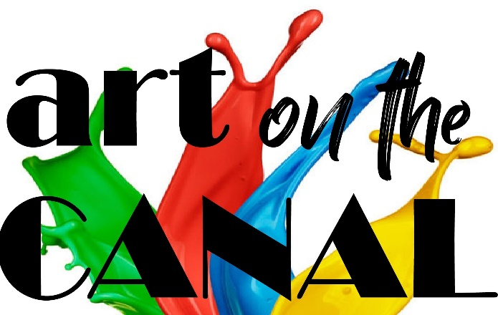

Destination: Canal Winchester
P.O. Box 45
Canal Winchester, OH 43110
Web: DestinationCW.org
eMail: info@destinationcw.org
(614) 270-5053

Art on the Canal – Art Stroll
Fine Art and Fine Craft Show and Sale
May 15, 2021 from noon to 6 pm
We’re excited to announce we will not be charging our artists and fine crafters a participation fee for our 2021 event. We understand that 2020 was a very challenging year and, with this in mind, we want to provide an exciting event in historical Canal Winchester that allows artists and fine crafters an opportunity to showcase and sell their works. We only ask that our vendors pay a registration fee to reserve their space which will be returned on May 15th at set-up. Vendors, of course, will still need to carry their own liability insurance.
(rain or shine)
Registration fee: $50.00 per space
We are pleased to invite you to apply for exhibition in the 2021 Art on the Canal Art Stroll.
Eligibility
1. We welcome any artist in the area of fine arts or fine crafts, who exhibits his or her own handmade works of art.
Fine art defined – fine art is art developed primarily for aesthetics or beauty.
Fine craft defined- Sometimes called decorative or applied art which also has to serve some practical function, such as pottery or most metalwork. Excellence in craftsmanship is reserved for work that shows the highest standards of quality. The work demonstrates a mastery of the medium, far beyond basic and intermediate proficiency skills. Attention to details and a thorough knowledge of the medium is demonstrated. Materials used are of the highest quality and of the best choice to enhance the overall design of the piece. The entire work is executed without technical flaw and it meets its intended purpose — e.g., if it’s a pitcher, it must pour, a jacket must fit, a drawer must glide freely. The appropriateness of technique and process are successfully united in a piece that shows excellence of craftsmanship and is functional.
2. All art must be original in concept, design and execution. We look for quality, originality and creativity. Some commercially manufactured parts may be incorporated; however, the design and execution of all items must be a product of the exhibiting artist. No manufactured jewelry, pieces made from commercially available kits, ceramics cast from commercial molds, or items imported or mass-produced for resale will be permitted, including items contracted for assembly to an artist’s specification.
3. Booth sharing is not allowed unless approved by the Committee.
4. Participants must exhibit the type and quality of work as shown in images submitted with application.
Cancellation of Exhibit Space
All cancellations must be made in writing. No refund of registration fee will be given to those who fail to set-up the day of the event.
Application for Vendors
This application does not guarantee acceptance. This is a juried event. Those accepted will be notified within two weeks of receiving the application. Those participants who apply after April 15th may not be included in the printed materials.
1. Participants will agree to publicly display their art and fine craft in their assigned location on May 15th from noon to 6 pm.
2. All participants need to be prepared and present for the event at their assigned location from noon to 6 pm.
3. The participants are responsible for their work at all times and agrees to accept any problems, damages, etc. that might be incurred from basic exhibit and display.
5. Participants will make available business cards, contact and sales information for potential customers.
6. If merchandise is sold as a result of the event, all proceeds will go solely to the artist. The artist will be responsible for all related taxes from the sale of his or her work. The artist will determine the acceptable method of payment and delivery terms with the buyer.
7. Participants are requested to promote the event through personal and professional e-mails, blogs/social media and mailings.
8. Participants will provide a detailed description of art they are bringing and a description/pictures of their typical set-up/space along with this application.
9. Participants are required to bring their own 10 x 10 tent, tables, display materials and chairs.
10. Participants are required to carry their own liability insurance and provide proof of this insurance prior to the event. No artists will be allowed to set up without proof of this insurance. If an artist needs event insurance for one day, ACT Insurance, Safeguard.com, and directeventinsurance.com have very good rates.

Provided by Destination:Canal Winchester
1. News Press Release to local media outlets.
2. General information posters strategically located.
3. Printed fliers/maps.
4. Professional graphics or images to be used with social media promotions.
5. Certificate of Insurance for using city property.
6. Event signage
7. Facebook advertising
Legal Agreement:
I hereby release and forever discharge (hold harmless) Destination:Canal Winchester (D:CW), and all sponsoring organizations, committee and board members from any responsibility, personal liability, claims, loss or damage arising out of my participation in the event. If accepted, Destination:Canal Winchester has my permission to reproduce my artwork through the images I have submitted for the purpose of promoting, advertising and marketing their shows. I agree to abide by all payment and cancellation schedules. I further consent to the enforcement of all D:CW rules as set forth in the above application Terms & Conditions of Participation, and in any subsequent communications.
By submitting my application either on-line or via paper application, I confirm that I have read and agree to the Terms & Conditions of Participation and the above Legal Agreement. Furthermore, I agree to abide by all show rules, regulations, & payment schedules.

Please complete the following form and submit with payment:
Artists and fine crafters, please check all that apply:
_____ Have my own studio space within historic downtown Canal Winchester
_____ Would like one space ( 10 x 10 )
_____ Would like more than one space (each additional 10 x 10 space is an additional registration fee)
Total number of spaces requested ______
Artists and fine crafters will provide a detailed description and pictures of art they are bringing and a description/pictures of their typical set-up/space.
Contact Information (Name and studio name)
_______________________________________
Phone ______________________________ E-mail _________________________________

Signature ___________________________ Date ___________________________________
If payment is not sent with application, it must be sent with in 10 days of acceptance notification. Checks should made out to Destination: Canal Winchester and mailed to PO Box 45, Canal Winchester, Ohio 43110. You may also pay with Give Lively by the link on the Art on the Canal page on the Destination: Canal Winchester web site.

